

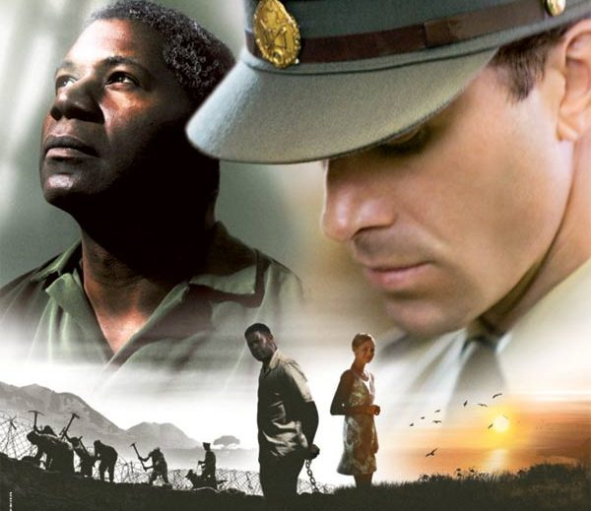

Goodbye Bafana

ik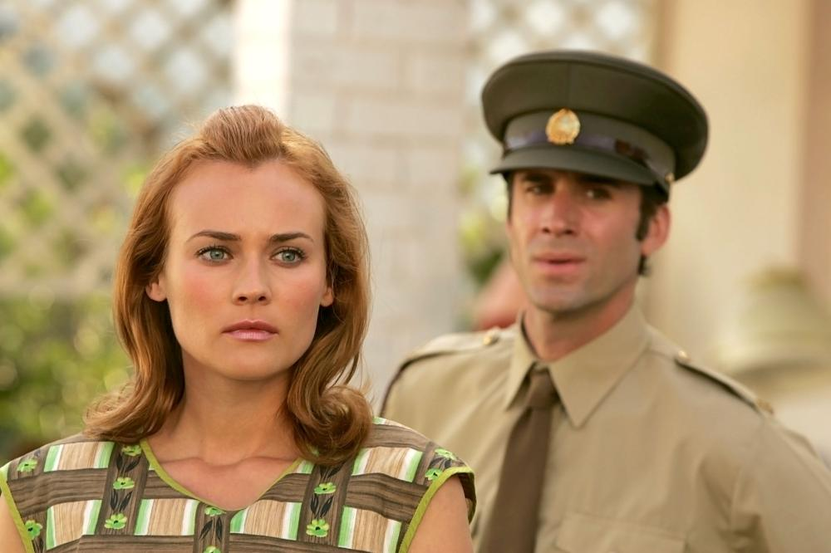

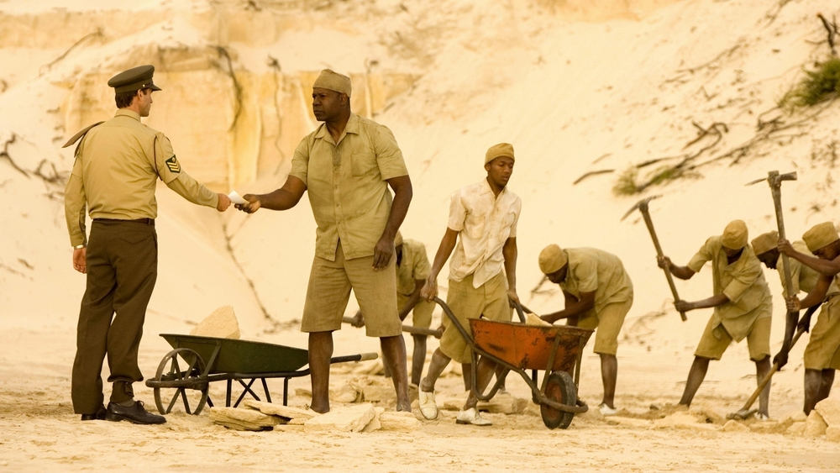

is h

Dennis Haysbert

Diane Kruger

Joseph Fiennes

Directed by Bille August

Inspired by the story of Nelson Mandela

Taken from a true story, “Goodbye Bafana” describes the unlikely and profound relationship between James Gregory, a racist prison warder from South Africa and his prisoner Nelson Mandela. Gregory, who speaks Mandela’s mother tongue, received the order to spy on him. Despite their differences, a beautiful friendship will start. With the influence of Mandela, Gregory’s vision of the world will change completely. “Goodbye Bafana” gives a powerful and a captivating message of courage, hope and humility.

An intellectual, strong and shocking movie.