Ingredients and quantity | Equipment and utensils
Flour 5oz (140g)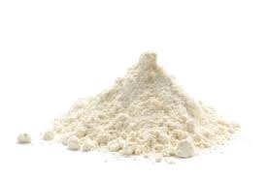  Butter 4oz (120g)  Sugar 4oz (120g)  Egg 2  Milk 3 tablespoons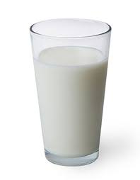  Yeast ½ sachet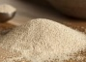  Bicarbonate 1 teaspoon  Vanilla extract 1 teaspoon | 1 muffin tin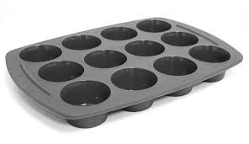  Oven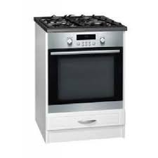  Mixing bowl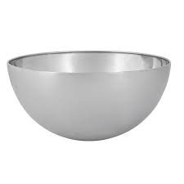  Saucepan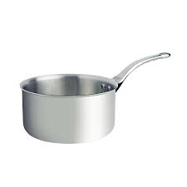  whisk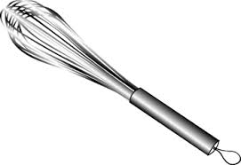
CUPCAKES

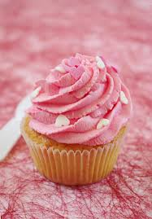

1. Pre-heat the oven to 392 degrees F (200°C).
2. Melt butter in a saucepan.
3. Put sugar in a mixing bowl.
4. Add eggs, flour, bicarbonate and yeast.
5. Mix with a whisk.
6. Add milk and vanilla.
7. Fill the muffin tin three-quarters with the preparation.
8. Bake for 20 minutes.
9. Cool the cupcakes.

