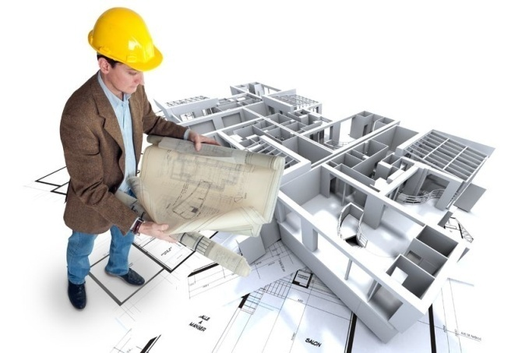

Architect

An architect has to create plans and sketches of buildings, monitor the development projects and manage construction sites.

Studies: After passing your A-levels mathematics and science (It’s the equivalent of the Baccalauréat Scientifique in France) , you will have to get a Master’s degree or a PhD in architectural studies.

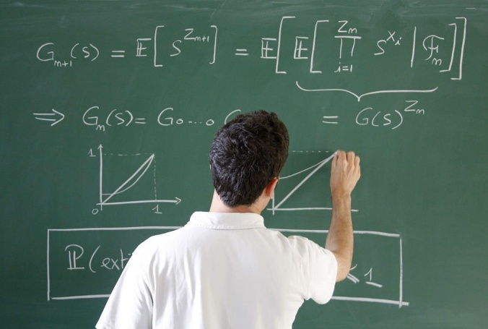

So, to become an architect, you will have to be particularly good at maths and physics to draw plans that require the use of physical laws. In addition, you will have to be good at art and be handy and rigorous because you will have to draw the outside of the buildings.

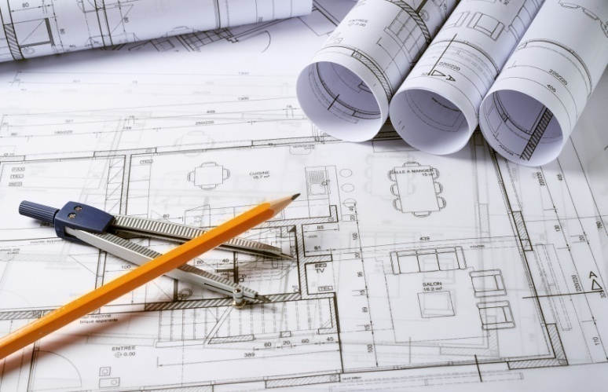

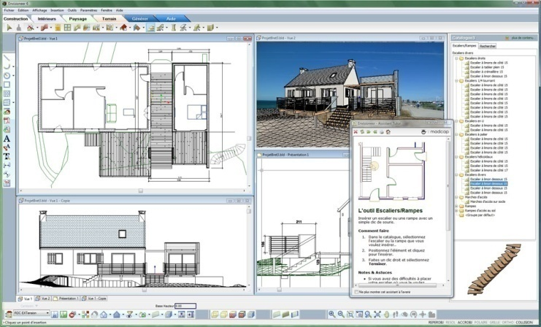

Secondly, knowing how to use the appropriate software is one of the most important skills of an architect, then you will have to be good at I.T and computing.

You will have to be creative to design, consequently art history is also necessary because architecture is an art and you will have to know the history of construction to improve the techniques  of construction.

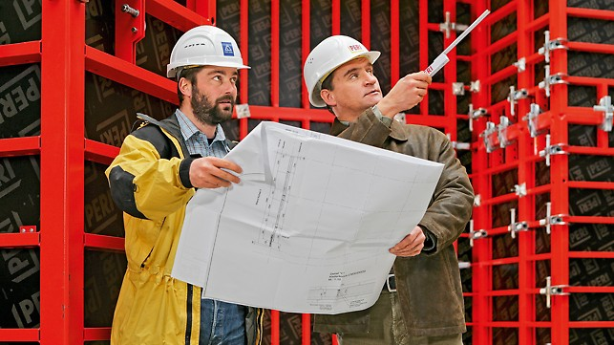

Being an architect requires many qualities such as being sociable and efficient because you will have to work in a team or also be well organized. An architect has to work outdoors as much as indoors and wear special clothes so you will have to be polyvalent. However, you will be able to earn a lot of money and lead a normal family life. Nevertheless, you will sometimes have very long working days when the constructions start.

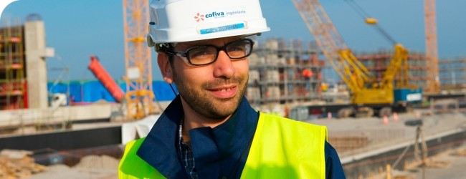

By Jessi.