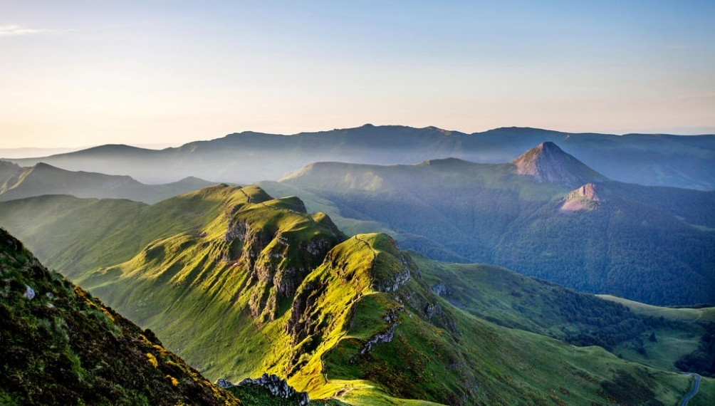

Reminder: A guide is a person who guides tourists in a place. He has to answer their questions and explain the history, the cultures and the customs of the place…

**Tourist Guide !**

**Qualities !**

If you become a guide, you will have to have many qualities. For instance you will have to be fit because when you become a guide you will have to walk a lot…You will also have to be energetic, tactful and resourceful…In addition , you will have to be articulate and have a good memory because you will have to explain many things…

**In school !**

To become a good guide, you will have to be good at foreign languages because you will have to speak with people from all over the world…

You will also have to be good at History and Geography because if you become a guide for a place, a city or a historic building, you will inevitably have to know the history of the place and where it is…Nevertheless, you won’t have to be good at Maths, Physics, science or computing…However, you will have to do long studies and do a training course with an experienced guide…

And it’s also recommended to have a driving license…

**Private life !**

When you become guide, you will have to get up early and work at weekends…Nevertheless, you will be able to take some days off…

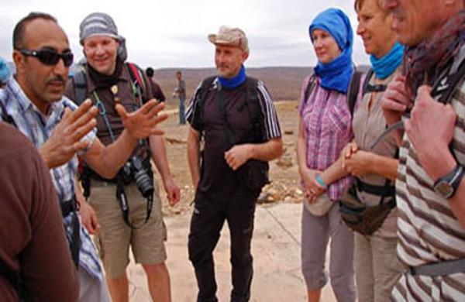

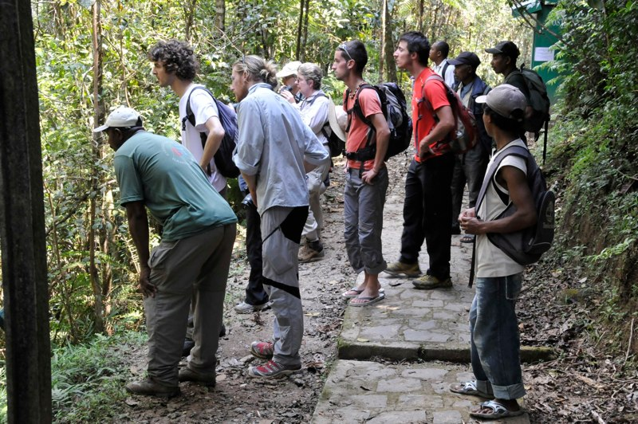

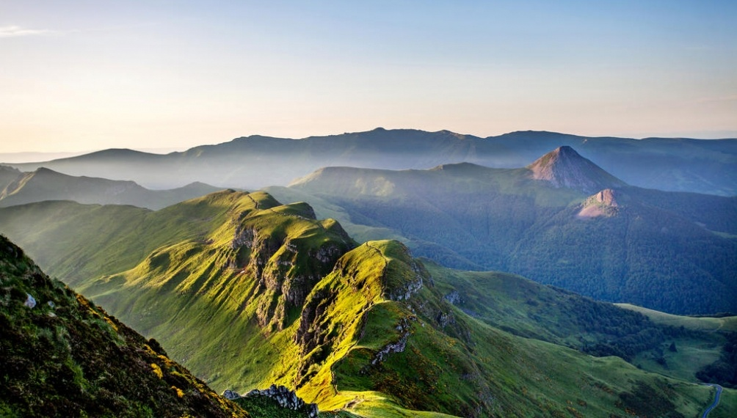

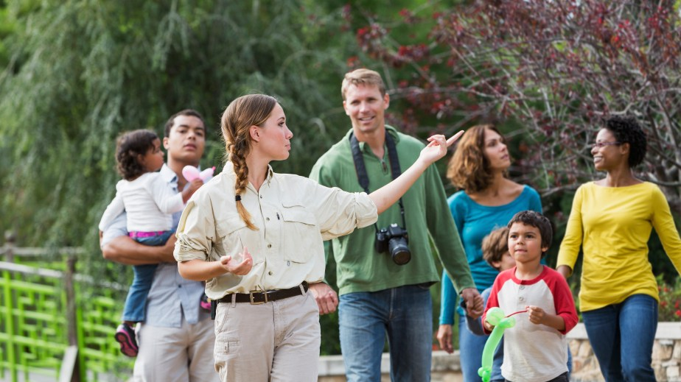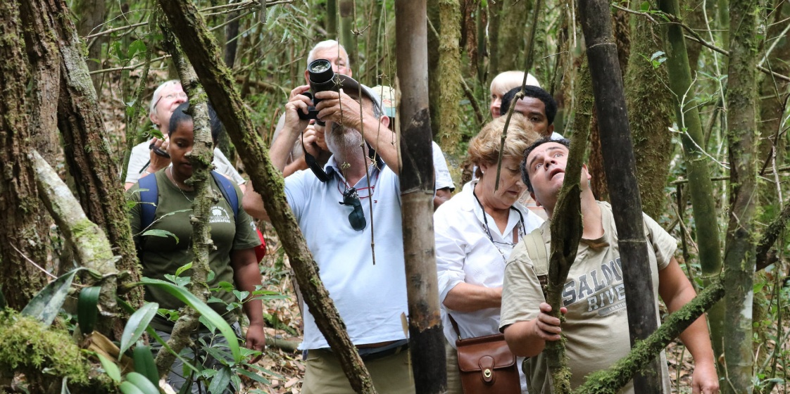

**By Aina**

**There are many sorts of guide :**

-Guide in a national park

-Guide in a city or a historic building

-Tour Guide

And many more…

**Working Conditions !**

In this job, you may have to walk a lot and work outdoors…You will be able to finish early… however, you will have to start early and have long working days(You may have to work more than 140 hours per month)…

To do this job, you will also have to have special equipment and work in a team…

If you become a guide, you can work everywhere, it depends on what sort of guide you become…